*jvm.dll*

We need to know about jvm.dll also. This is the actual java virtual machine implementation in windows environment and it is part of the JRE. A ‘C’ program can use this jvm.dll directly to run the [jvm](http://javapapers.com/core-java/differentiate-jvm-jre-jdk-jit/" \o "Differentiate JVM JRE JDK JIT).

*java.exe*

java.exe is a Win32 console application. This is provided as a helper so that, instead of using jvm.dll we can execute java classes. As it is a Win32 console application, obviously it is associated with a console and it launches it when executed.

*javaw.exe*

javaw.exe is very similar to java.exe. It can be considered as a parallel twin. It is a Win32 GUI application. This is provided as a helper so that application launches its own GUI window and will not launch a console. Whenever we want to run a GUI based application and don’t require a command console, we can use this as application launcher. For example to launch Eclipse this javaw.exe is used. Write a small java hello world program and run it as “javaw HelloWorld” using a command prompt. Silence! nothing happens then how do I ensure it. Write the same using Swing and execute it you will see the GUI launched. For the lazy to ensure that it is same as java.exe (only difference is console) “javaw HelloWorld >> output.txt”. It silently interprets and pushes the output to the text file.

We can execute the GUI application using both java.exe and javaw.exe If we launch using java.exe, the command-line waits for the application response till it closes. When launched using javaw, the application launches and the command line exits immediately and ready for next command.

*javaws.exe*

javaws.exe is used to launch a java application that is distributed through web. We have a jnlp_url associated with such application. We can use as “javaws jnlp_url” to launch the application. It downloads the application from the url and launches it. It is useful to distribute application to users and gives central control to provide updates and ensures all the users are using the latest software. When the application is invoked, it is cached in the local computer. Every time it is launched, it checks if there is any update available from the distributor.

Primitives (From Clive Scott Videos)

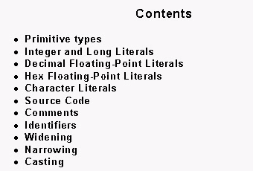

++++++++

Q) What is Class object?

A) Nothing gets type casted to Class. Every Object in Java belongs to a certain class. That's why the Object class, which is inherited by all other classes, defines the getClass() method.

getClass(), or the class-literal - Foo.class return a Class object, which contains some metadata about the class:

* name
* package
* methods
* fields
* constructors
* annotations

A class literal is an expression consisting of the name of a class, interface, array, or primitive type, or the pseudo-type void, followed by a '.' and the token class.

The type of C.class, where C is the name of a class, interface, or array type is Class<C>.

The type of p.class, where p is the name of a primitive type is Class<B>, where B is the type of an expression of type p after boxing conversion.

The type of void.class is Class<Void>.

**It is a compile-time error if the named type is a type variable or a parameterized type or an array whose element type is a type variable or parameterized type.**

**It is a compile-time error if the named type does not denote a type that is accessible and in scope at the point where the class literal appears.**

*The meaning of above two statements is:*

The named type cannot be a type variable (e.g. T if you have a parameterized class such as SomeClass<T>), parameterized type (e.g. can't have ArrayList<String>.class, only can have ArrayList.class), or an array whose element is a type variable (e.g. can't have T[].class in a class SomeClass<T>) or parameterized type (e.g. can't have ArrayList<String>[].class). Last two points just mean that these literals are subject to the same access/scoping rules (i.e. private, protected, etc.) that other variables are.

The SomeClass.class syntax is a way to get from SomeClass to the corresponding instance of Class.

A class literal evaluates to the Class object for the named type (or for void) as defined by the defining class loader of the class of the current instance.

* a.getClass() returns the runtime type of a. I.e., if you have A a = new B(); then a.getClass() will return the B class.
* A.class evaluates to the A class statically, and is used for other purposes often related to reflection.

So, for example, if a method of yours is given an object, and you want to process it in case it is annotated with the @Processable annotation, then:

public void process(Object obj) {

if (obj.getClass().isAnnotationPresent(Processable.class)) {

// process somehow;

}

}

In this example, you obtain the metadata about the class of the given object (whatever it is), and check if it has a given annotation. Many of the methods on a Class instance are called "reflective operations", or simply "reflection”.

Note also that enums and interfaces also represent a Class object, and have the respective metadata.

To summarize - each object in java has(belongs to) a class, and has a respective Class object, which contains metadata about it, that is accessible at runtime.

The primitive Java types ({@code boolean}, {@code byte}, {@code char}, {@code short}, {@code int}, {@code long}, {@code float}, and

{@code double}), and the keyword {@code void} are also represented as {@code Class} objects.

++++++

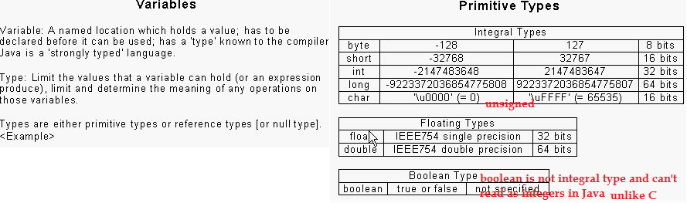

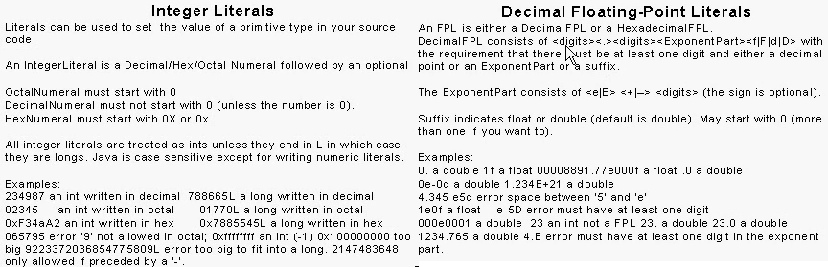

+++++++++++

**float** f1 = 1.0e10f; // equivalent to 1 * 10^10

**float** f2 = 0x1P10f; // equivalent to 1 * 2^10

Floating point literals cannot be represented in octal.

**import** java.math.BigDecimal;

System.*out*.println(**new** BigDecimal(2.0E10).toPlainString()); // output 20000000000

+++++++++++

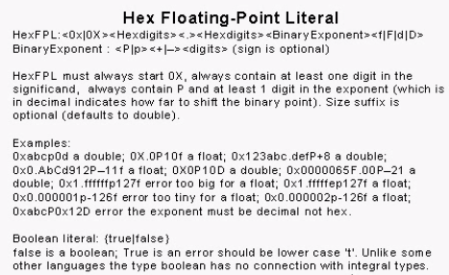

/**************************** **Character Set and Character Encoding*************************/**

Byte is the size of an individual cell of addressable memory.

In 1970’s Byte was 17 bits, 13 bits etc..

Kibibyte = 2^10bytes, mebibyte=2^20bytes, gebibyte=2^30bytes.

Programs that read and write the same text data have to agree on what number corresponds to what character.

It would be a huge mess, if every program in the world, decided that it has its own way of mapping numbers to characters.

So, that’s why we have, what are called **Character Set**.

A **Character Set** is a standard agreed upon mapping from Characters to Numbers.

Most widely used **Character Set** from decades is ASCII which was created in 1950.

As ASCII is American, It mostly has English alphabets.

A **Whitespace Character** represents Spacing.

There are many Whitespace characters - space, tab, linefeed, carriage return

In 1950’s, The only way, the computer displays the text is by printing.

Printers back in those days, worked as Electronic Typewriters, so paragraph mark was a combination of CarriageReturn&LineFeed.

When we work with text on Computer, We usually think of pressing ENTER key as inserting paragraph mark, But there is no such character in ASCII, There is LineFeed & CarriageReturn in ASCII. But the problem is that, Not all programs agree, about the standard way to represent paragraph mark. Whether you should use LineFeed&CarriageReturn or anyone? For long time the prevailing situation in UNIX was to use LineFeed as paragraph mark, on MAC systems use CarriageReturn as paragraph mark, where as Microsoft decided CarriageReturn followed by LineFeed as Paragraph mark. What this then meant is, When you write text on one system and transmitted to another, you either end up with too many or too few paragraph marks. Today, this isn’t a bigger problem as it once was, Because, most programs which read ASCII text interpret LineFeed or CarriageReturn or Combination as paragraph mark.

Whitespace characters in ASCII are actually considered as **Control Characters**. A Control Character is a character, which when read by the program, is meant to trigger an action. LineFeed Character and CarriageReturn Character, those actually represent actions.

Another control character is FormFeed, that means, advancing the complete page. Today’s programs treat BELL character as space or no Character at all.

In plain text data, Data consists of just sequence of characters. There is no formatting information, whatsoever. In the plain text data, There is no way to represent below information like,

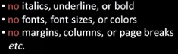

So, **plain text** is made up of just characters.

So, There is a distinction between a Character and actual visual representation of that character.

So, An actual visual representation of a Character is called **Glyph**.



J here has two different glyphs.

**Character encoding** is the scheme for representing characters as bits.

ASCII has encoding of 1 byte per character.



**Unicode standard** created in 1990’s, encompasses a **Character Set** and its various **Character encoding**s.

Unicode character set unlike ASCII is meant to encompass all of the world’s languages, whereas ASCII only has 128 characters.

Unicode standard actually has space for over million characters.

More precisely, Unicode character set is comprised of planes.

Each plane has 65536 characters and there are 17 of these planes.

Total 1, 114, 112 characters.

Each one of these million plus of mappings of characters to numbers in Unicode is called a **Code Point**.

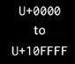

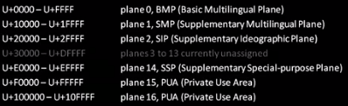

**Plane 1** consists mainly of dead languages from ancient times and musical notation symbols and mathematical notation symbols.

Chinese/Japanese/Korean Ideographs are encoded in **Plane 2**.

Next 11 planes are almost unused.

**Plane 15 16** are reserved for use by Special applications.

**Plane 14** has to do with formatting and Data protocols.

In BMP, There are around 1000 Code Points, that aren’t assigned yet.

So,

Code Point 0x0020 is Space Character in Unicode where as in ASCII it is, 0x20.

Code Point 0x0041 is Character A in Unicode where as in ASCII it is, 0x41.

ASCII has basically one encoding scheme, whereas Unicode has several.

The simplest such encoding scheme in Unicode is called **UTF-32**.

**UTF** stands for Unicode Transformation Format.

**32** mean, We represent each character by 4 bytes.

Unicode characters are over million, so we need 21 bits, so UTF-32 is the nearest fit.

Following are the example Code Points in UTF-32.

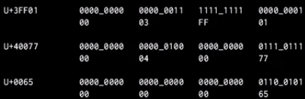

So, The obvious objection above is, this **UTF-32** encoding scheme really wastes quite a number of bits.

**UTF-16** is less straight-forward encoding technique to address this in Unicode.

In **UTF-16**, Code Points of **BMP** are encoded in 2 bytes.

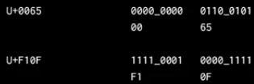

In UTF-16, Code Points outside **BMP**, Things get much more complicated with 4 bytes.

There are 16(0-15) planes excluding **BMP**.

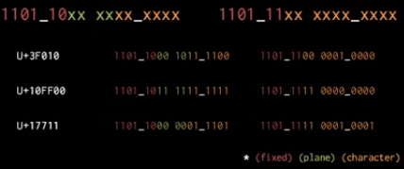

+++++++++

Q) You probably wondering, when program reads text in UTF-16, How can it tell the character which is encoded in 2 bytes apart from character which is encoded in 4 bytes? When program reads 4 bytes, Why would that read as one character instead of just 2 characters one after the other?

A) Well, The reason for the fixed bits at the start of these pairs, is that, in the **BMP** there are some **Code Points** which are reserved

They are not assigned to any characters. They are explicitly for this purpose and they are called **Surrogates**. They are Code Points as shown with below range:

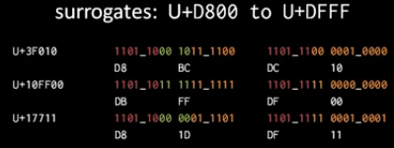

Because in a 4 byte character,

First pair always begins with, 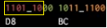, Those 2 bytes in hex always be in range **D800 – DBFF**.

Second pair always begin with, 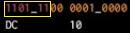, Those 2 bytes in hex always be in range **DC00 –DFFF**.

So, Consequently, A Program reading UTF-16 text can always tell, when a pair of bytes is part of a larger 4-byte character rather than something meant to be its own character, Because for example **D8BC** isn’t a valid character Code Point, it is a **Surrogate** Code Point.

Most programs that run on Windows, tend to favor UTF-16 format.

+++++++++

**UTF-8** is another encoding technique used in Unicode.

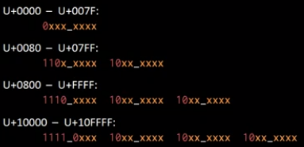

Below is an example, based on the above range:

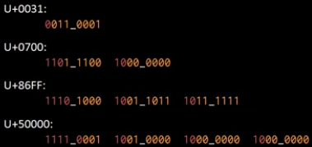

Another example:

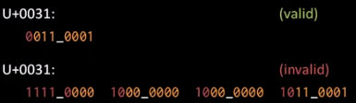

/**************************** **Character Set and Character Encoding*************************/**

/******************************************Character Literals*********************************/

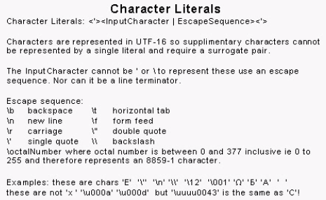

char ch1 = ''; //Line feed

//will be compiled as error line

char ch1 = '

';

char ch2 = '\u000d'; //Carriage return

//will be compiled as error line

'char ch2= ';

char ch3 = '''; // ' character

//will be compiled as error line

char ch3=''';

char ch4 = '\u005C'; // \ character

//will be compiled as error line

char ch4='\';

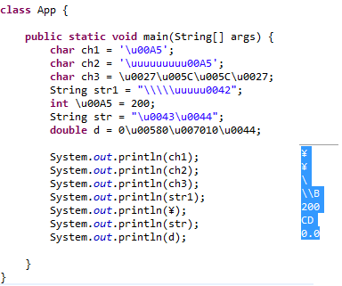

Section 3.3 of the JLS says:

UnicodeEscape:

\ UnicodeMarker HexDigit HexDigit HexDigit HexDigit

UnicodeMarker:

u

UnicodeMarker u

which translates to \\u+\p{XDigit}{4}

and

If an eligible \ is followed by u, or more than one u, and the last u is not followed by four hexadecimal digits, then a compile-time error occurs.

So you're right, there can be one or more u after the backslash. The reason is given further down:

The Java programming language specifies a standard way of transforming a program written in Unicode into ASCII that changes a program into a form that can be processed by ASCII-based tools. The transformation involves converting any Unicode escapes in the source text of the program to ASCII by adding an extra u - for example, \uxxxx becomes \uuxxxx - while simultaneously converting non-ASCII characters in the source text to Unicode escapes containing a single u each.

This transformed version is equally acceptable to a Java compiler and represents the exact same program. The exact Unicode source can later be restored from this ASCII form by converting each escape sequence where multiple u's are present to a sequence of Unicode characters with one fewer u, while simultaneously converting each escape sequence with a single u to the corresponding single Unicode character.

So this input

\u0020ä

becomes

\uu0020\u00e4

The second u means here "this was a unicode escape sequence to begin with" while the second one says "An automatic tool converted a non-ASCII character to a unicode escape."

This information is useful when you want to convert back from ASCII to unicode: You can restore as much of the original code as possible.

/******************************Character Literals**********************************************/

/*************************************String Literals******************************************/

In computer science, **string interning** is a method of storing only one copy of each distinct string value, which must be immutable. Interning strings makes some string processing tasks more time- or space-efficient at the cost of requiring more time when the string is created or interned. The distinct values are stored in a **string intern pool**.

public String intern()

Returns a canonical representation for the string object.

A pool of strings, initially empty, is maintained privately by the class String.

When the intern method is invoked, if the pool already contains a string equal to this String object as determined by the equals(Object) method, then the string from the pool is returned. Otherwise, this String object is added to the pool and a reference to this String object is returned.

It follows that for any two strings s and t, s.intern() == t.intern() is true if and only if s.equals(t) is true.

All literal strings and string-valued constant expressions are interned. String literals are defined in section 3.10.5 of the The Java™ Language Specification.

Returns:

a string that has the same contents as this string, but is guaranteed to be from a pool of unique strings.

/**********************************************String literals************************************/

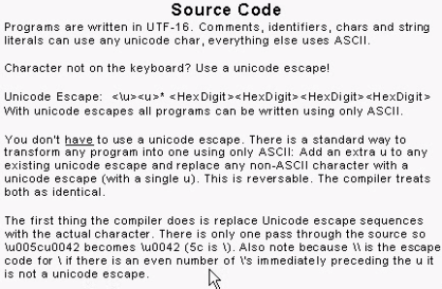

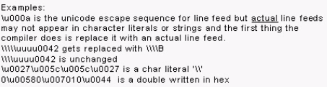

Comments:

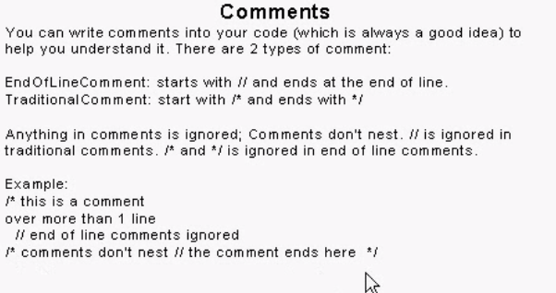

Identifiers

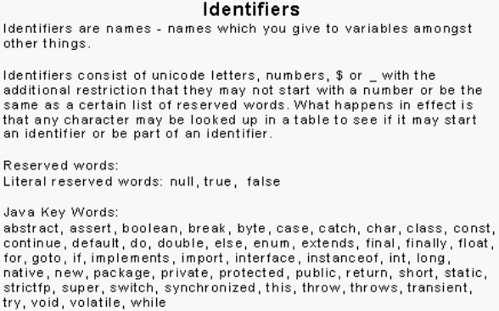

Widening

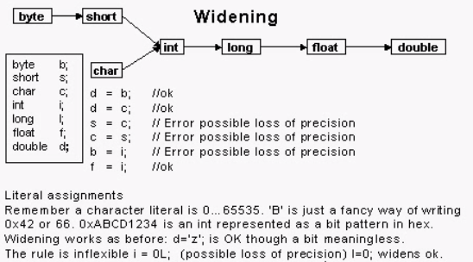

Implicit narrowing:

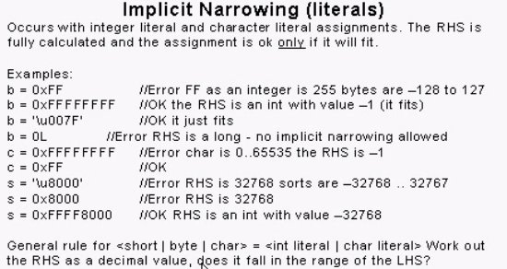

Casting:

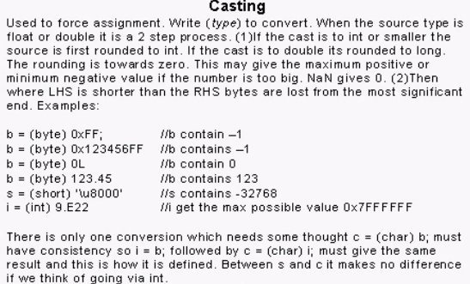

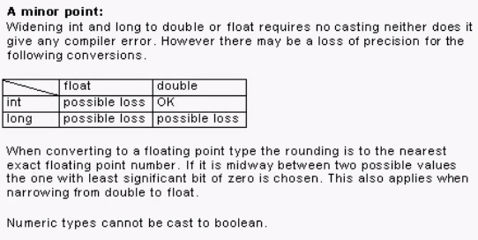

+++++++++++++++++++++++++++++++++++++++++++++++++++++++++++++++++++++++++++++++++

Operators (From Clive Scott Videos)

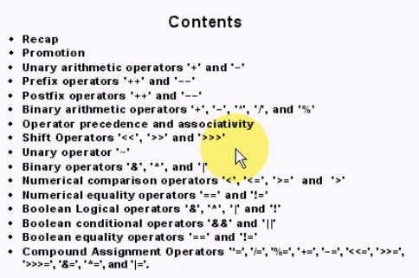

Recap of literals:

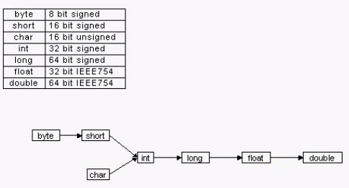

Stuff in yellow require a cast

Stuff in green does not require a cast.

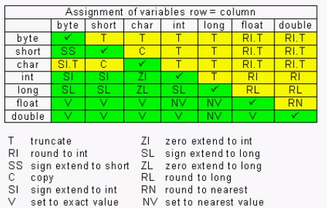

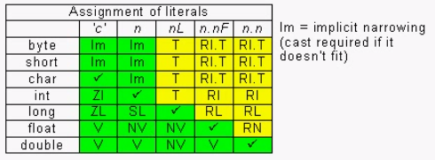

Promotion:

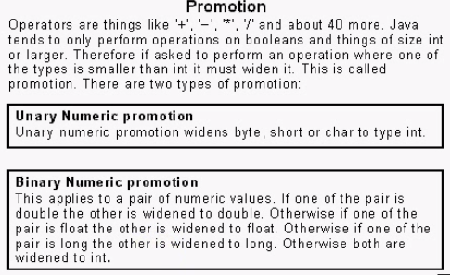

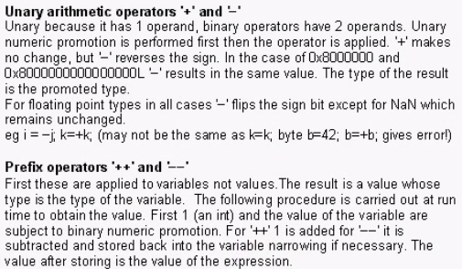

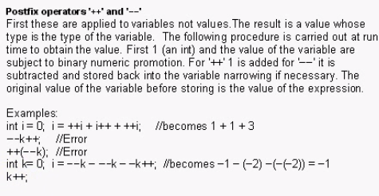

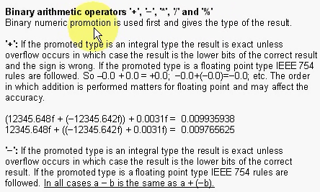

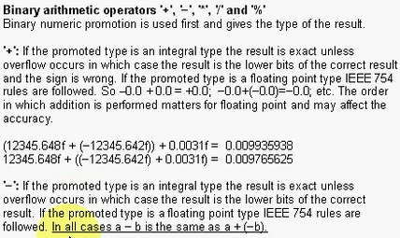

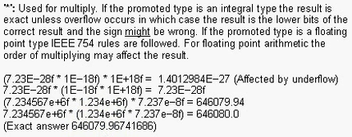

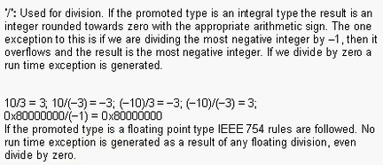

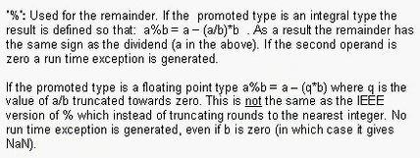

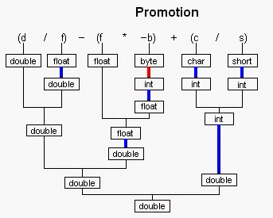

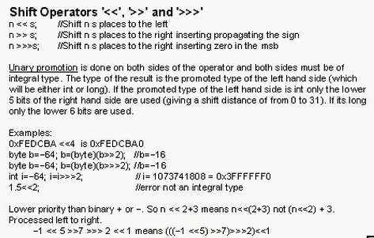

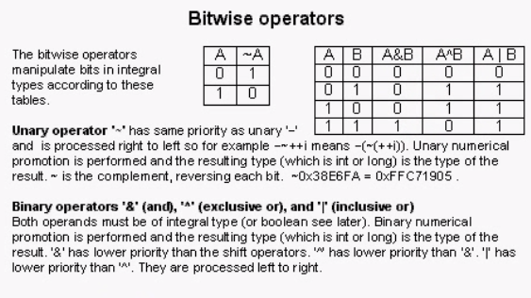

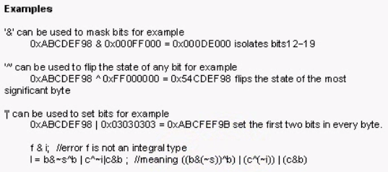

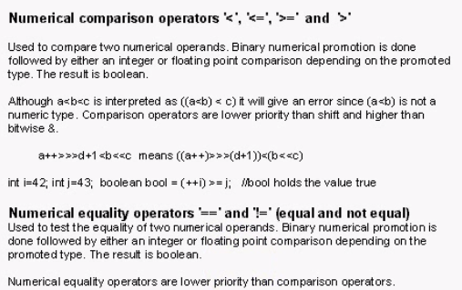

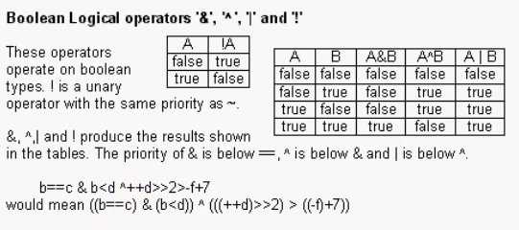

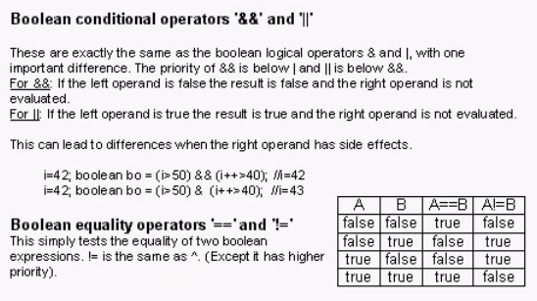

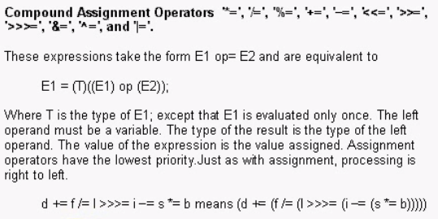

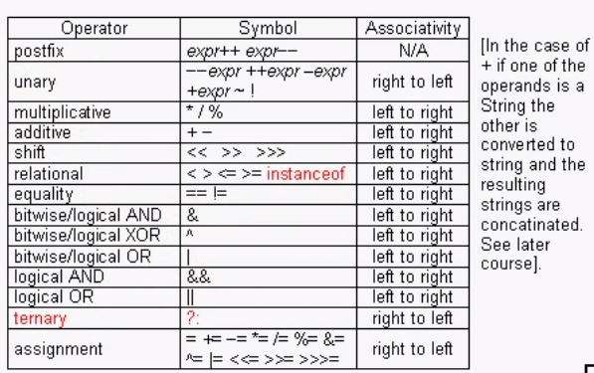

== is the operator that takes two operands; When both are objects, the references are compared, when both are primitive, compareTo() by the wrapper class is performed, when one is object and the other is primitive, it tries to unbox.

.equals() is overridden by most classes to compare properly, such that Integer.valueOf(5).equals(Double.valueOf(5.0)) actually works

+++++++++++++++++++++++++++++++++++++++++++++++++++++++++++++++++++++++++++++++++

First Look at Classes (From Clive Scott Videos)

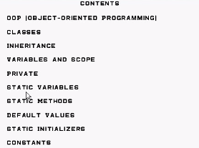

*Variables & Scope:*

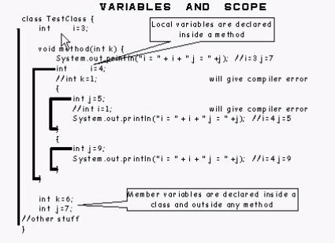

*Private Variables:*

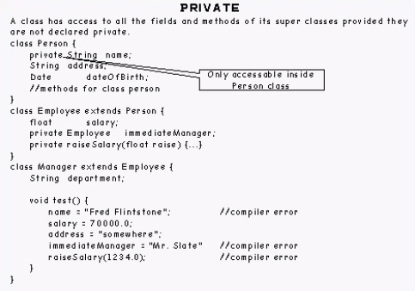

Static Variables:

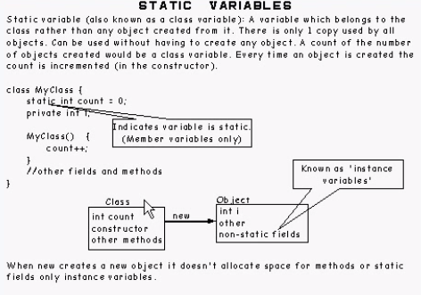

*Static Methods:*

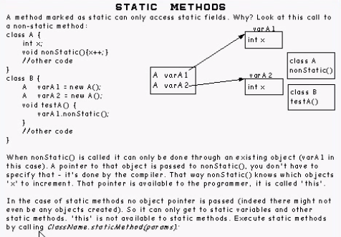

*Default Values:*

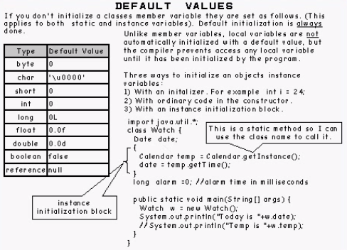

*Static Initializers:*

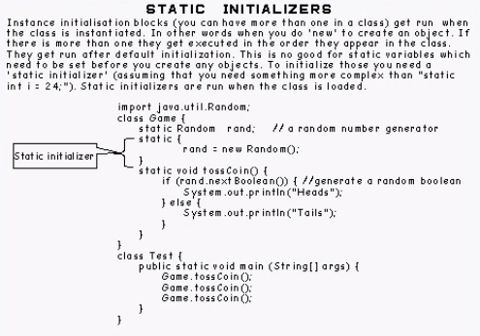

*Constants:*

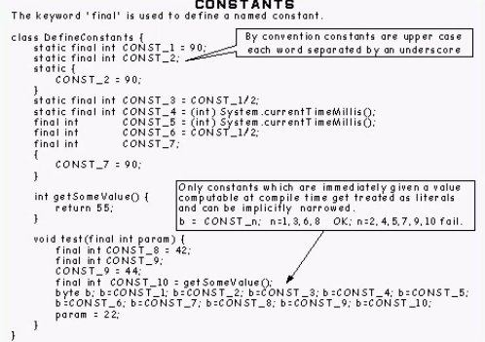

Points from Zor:

Methods applicable to all classes, like clone()/toString() are placed in Object class.

++++++++++++++++++++++++++++++++++++++++++++++++++++++++++++++++++++++++++++++++++++++++++++++++++++

Packages (From Clive Scott Videos)

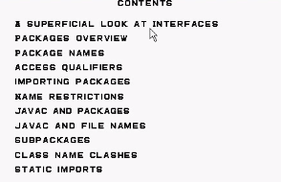

*Interfaces:*

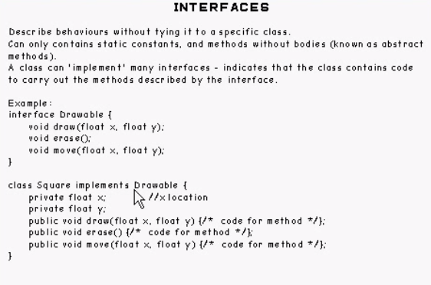

interfaces define common behaviour, abstract classes provide common implementations.

*Packages Overview:*

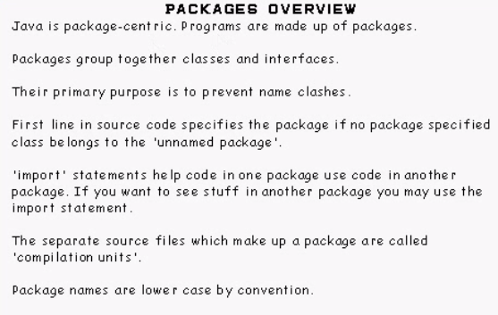

*Package Names:*

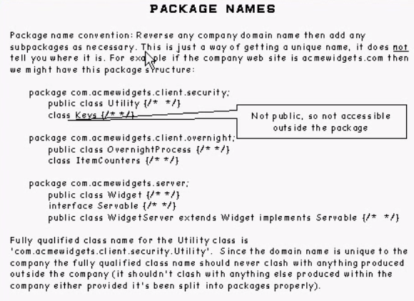

*Access Qualifiers:*

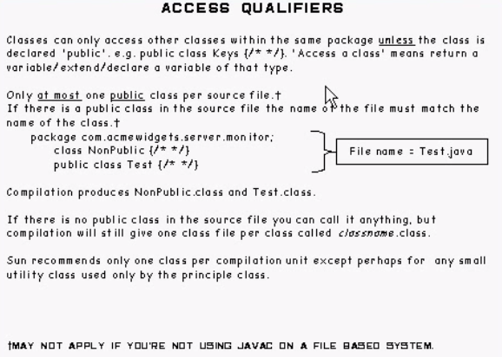

*Importing Packages:*

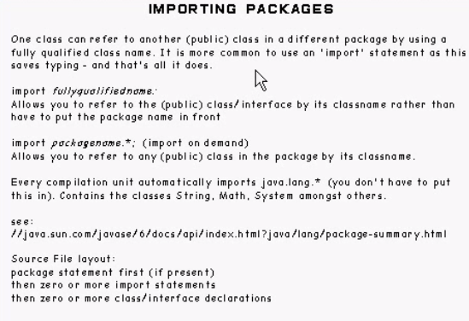

*Package name restrictions:*

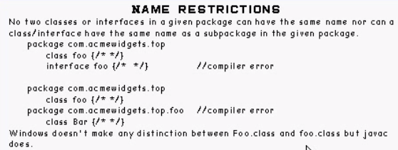

*Javac & Packages:*

Language spec says that fully qualified name of class should be unique.

The way javac compiler implements this spec is by mirroring package hierarchy using the file directory hierarchy.

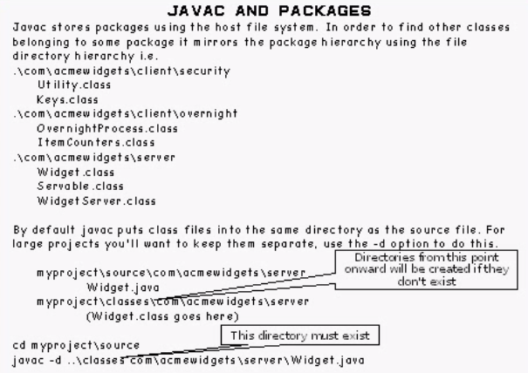

*Javac & File names (Unicode)*

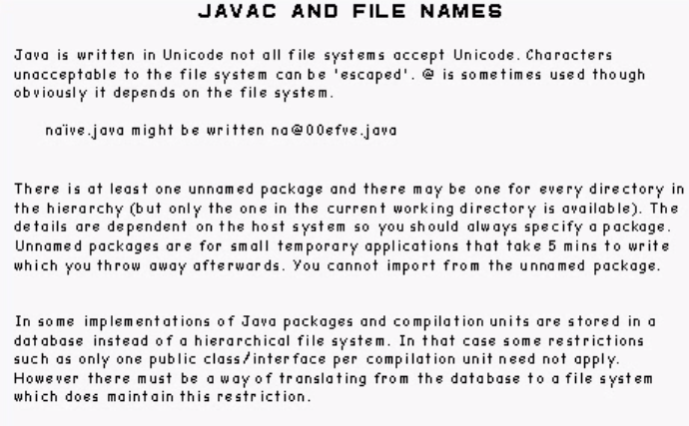

*Sub packages:*

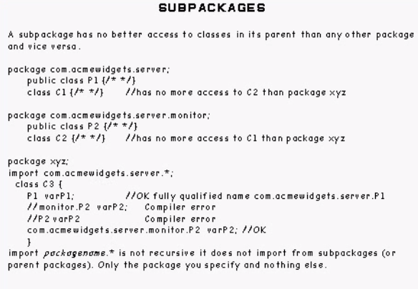

*Class name clashes:*

*Import on demand syntax:* **import** java.util.*;

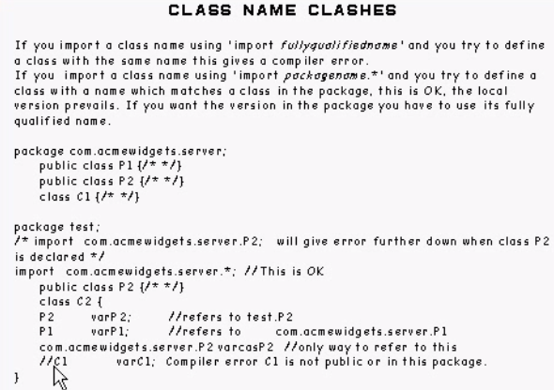

*Static imports:*

*Be extreme cautious to use this facility.*

**import** *only saves typing.*

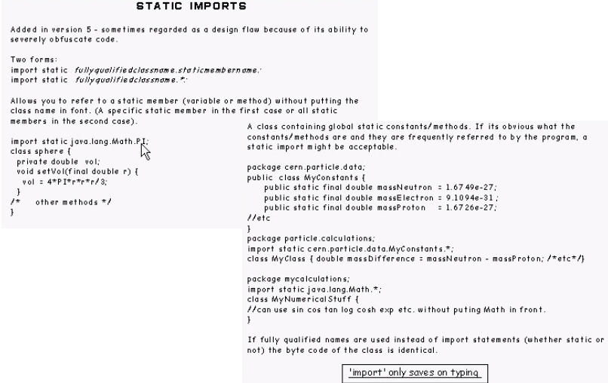

+++++++++++++++++++++++++++++++++++++++++++++++++++++++++++++++++++++++++++++++++++++++++++

Arrays (From Clive Scott Videos)

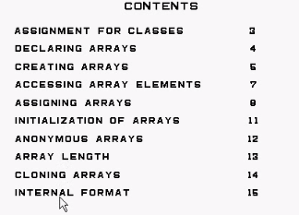

When you declare int a = 1;, you're really saying a is a variable which stores a primitive type - int.

When you declare int[] a = {1};, you're really saying a is a variable which stores an object - an int[].

Arrays are an object because they are not primitive. Variables of such can also be null for this reason.

And for your second point - "An object is a class instance" I have no clue what to say about that, it's basic OOP. Classes are what you write in source code, or "defined types", and objects are what's constructed by invoking new on that type's constructor.

So really, look at this:

class Ball extends Throwable {

// This is a class.

}

public class Main {

{

Object ball = new Ball();

// "ball" is an object. It's also an object of instance Ball, because it's invoked by that type.

throw ball; // But it is also an Exception object from inheriting Throwable which inherits from Exception.

// So we can do stuff with it that we could with Exception, like throw.

}

}

The type C[] is of its own type. It just doesn't have an accessible class because that class is held and invoked in runtime.

You can access that class with reflection.

[null, null, null, null] is the state of the object of type class [LC after running C[] c = new C[4];

It's an instance created by runtime.

object of type int[](subclass of Object) are constructed in run-time and these objects behave like any other object of particular class(say class C).

so, similarly type C[] is subclass of Object class? where object is instantiated in runtime? yes

/* dummy.java*/

class C{

private int i;

public C(){

i=0;

System.out.println("Am in constructor");

}

};

public class dummy {

public static void main(String[] args){

C[] c = new C[4];

System.out.println(c.length);

}

};

You will get a [] which is of state [null, null, null, null] which is then blue-stamped to C[] so it's typesafe. null is of no type.

any non-primitive type is of subclass Object. Arrays makes a special case because the type is not explicitly constructed and is instantiated in runtime.

If an array is not an array of primitive types, the it follows the same rules of assignment. Size is irrelavant.

Assignment for Classes:

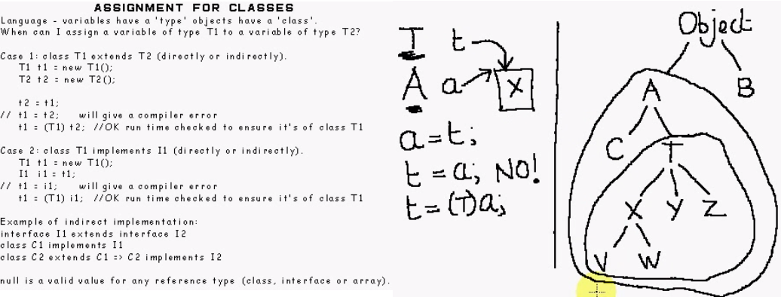

Declaring Array variables:

The Java Language Specification [section 4.3.1](http://java.sun.com/docs/books/jls/third_edition/html/typesValues.html#4.3.1) starts off with:

An object is a class instance or an array.

In the Java programming language arrays are objects (§4.3.1), are dynamically created, and may be assigned to variables of type Object (§4.3.2). All methods of class Object may be invoked on an array.

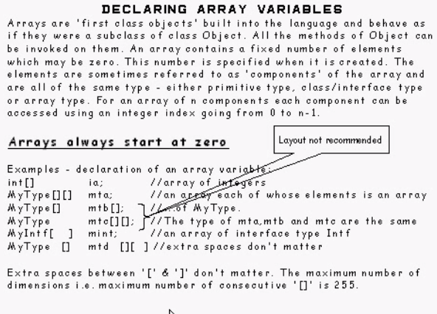

Creating Arrays:

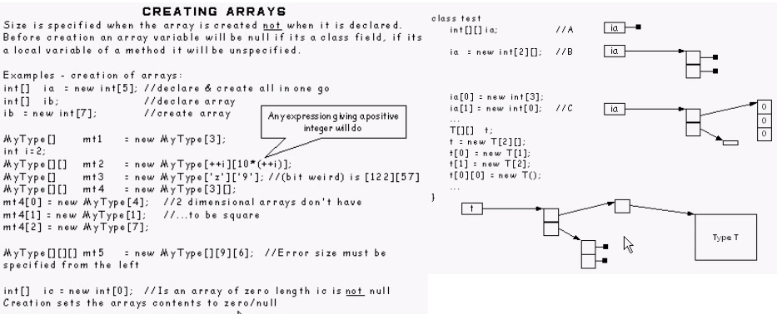

Accessing array elements:

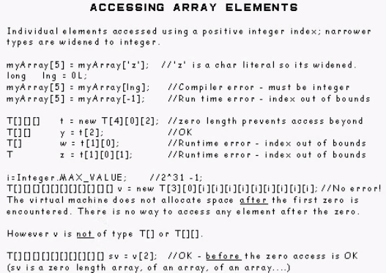

Accessing array elements continued….

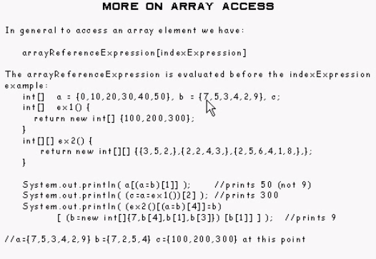

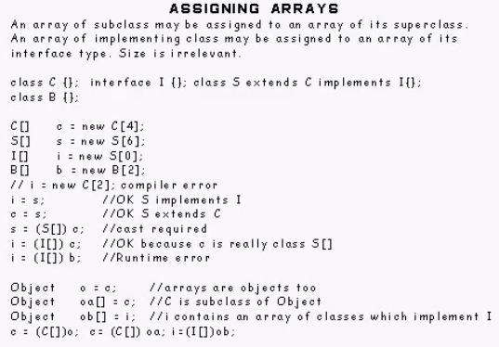

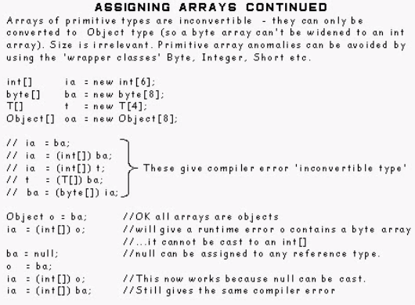

The view of an object depends on type of reference.

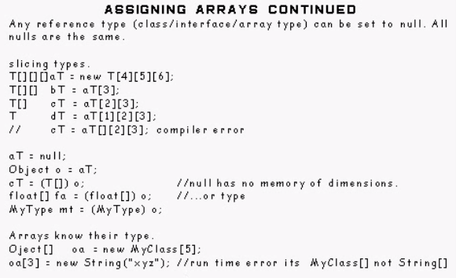

Initialization of Arrays:

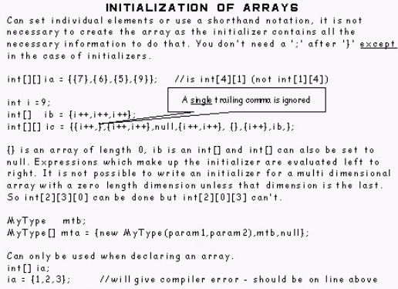

Anonymous Arrays:

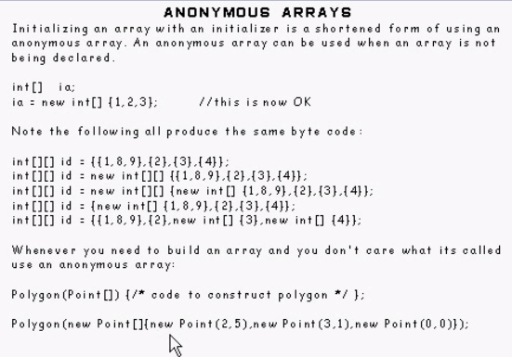

Array Length:

When you say

Object[][][] aT = **new** Object[1][2][3];

aT[0][0][0] = aT[0]; //mean above (new Object[2][3]) is assigned

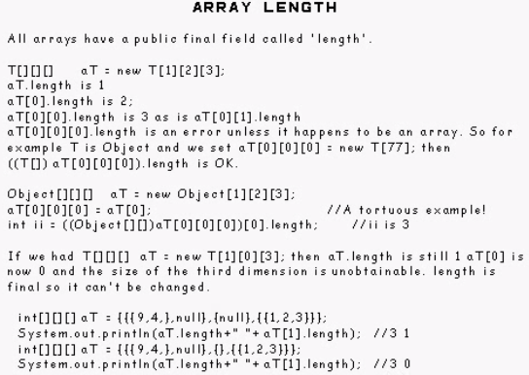

Cloning arrays:

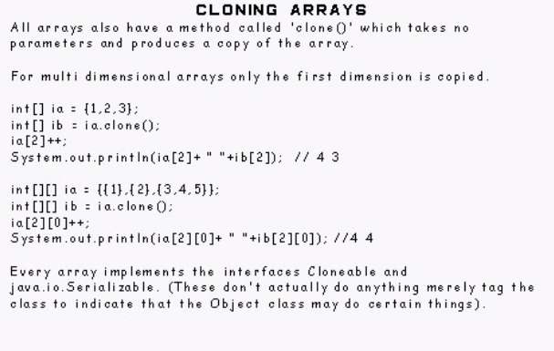

Internal Type Format:

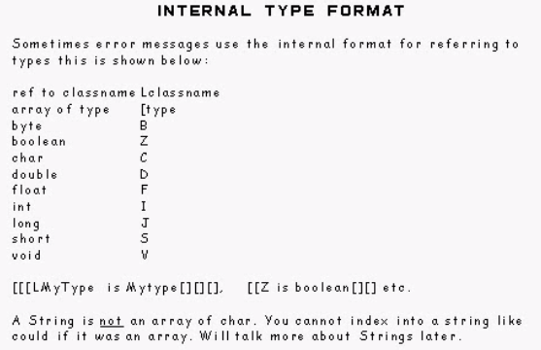

Points From Zor:

Below code gives problem because, you just created 3 reference variables obj[0] obj[1] obj[2]

You also need to allocated memory for each of these 3 reference variables, something like, obj[0] = **new** Test();

**class** Test{

**int** a;

}

**public** **class** App {

**public** **static** **void** main(String[] args) {

Test[] obj = **new** Test[3];

obj[0].a = 2; //Nullpointerexception

obj[1].a = 3;

obj[2].a = 4;

System.*out*.println(obj);

}

}

Arrays are objects in Java derived from Object class.

++++++++++++++++++++++++++++++++++++++++++++++++++++++++++++++++++++++++++++++++++++++++++

Instance operator (From Clive Scott Videos)



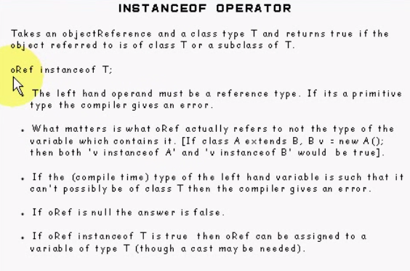

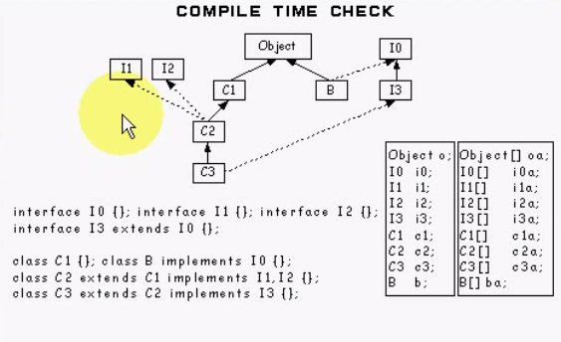

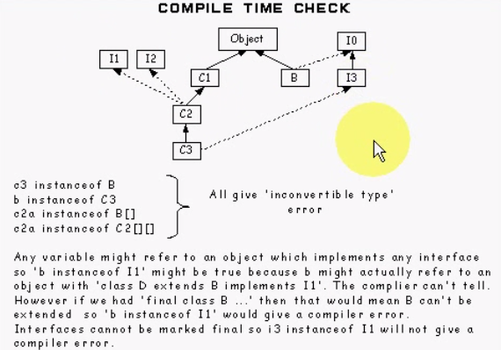

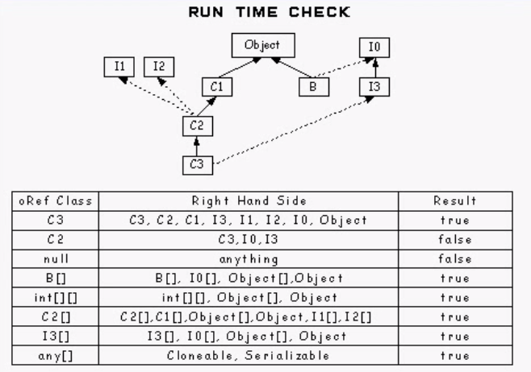

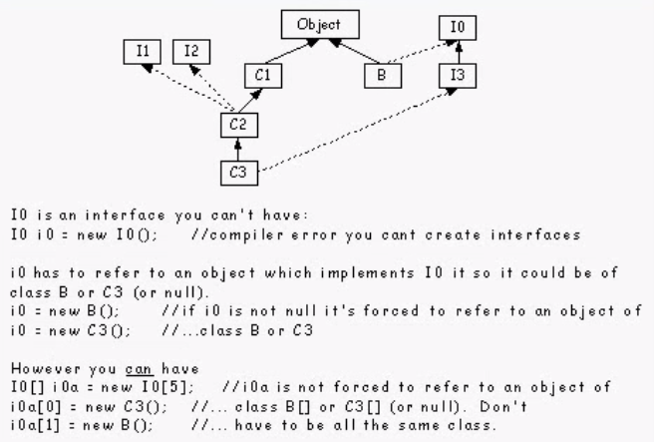

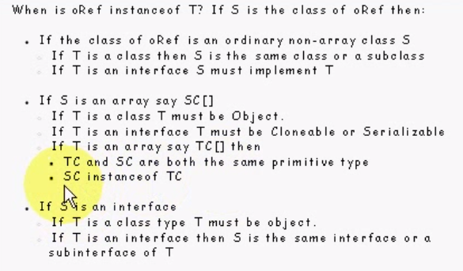

++++++++++++++++++++++++++++++++++++++++++++++++++++++++++++++++++++++++++++++++++++++++++

Auto Boxing (From Clive Scott Videos)

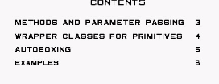

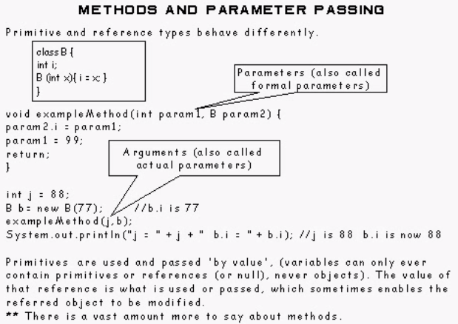

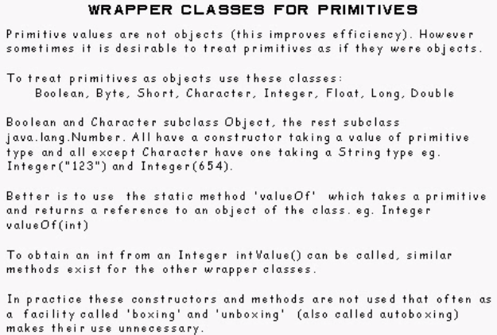

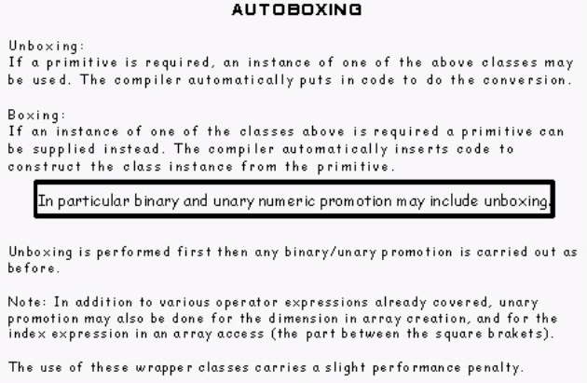

**ArrayList**<**Integer**> intList = **new** **ArrayList**<**Integer**>();  
intList.add(1); *//autoboxing - primitive to object*  
intList.add(2); *//autoboxing*  
        
**ThreadLocal**<**Integer**> intLocal = **new** **ThreadLocal**<**Integer**>();  
intLocal.set(4); *//autoboxing*  
  
**int** number = intList.get(0); *// unboxing*  
**int** local = intLocal.get(); *// unboxing in Java*

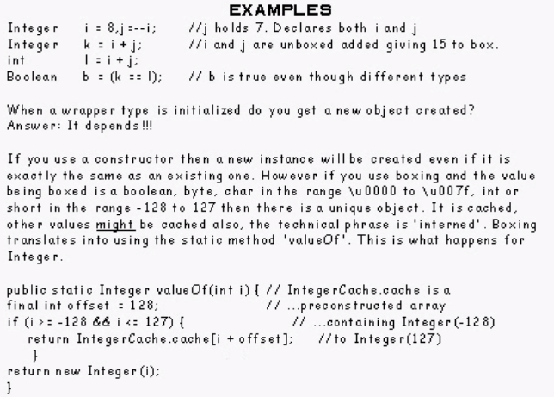

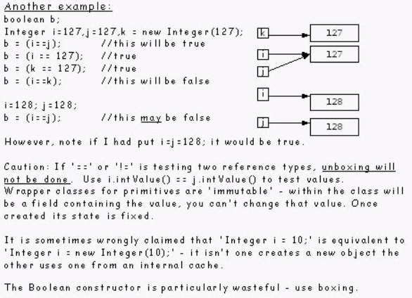

++++++++++++++++++++++++++++++++++++++++++++++++++++++++++++++++++++++++++++++++++++++++++

Ternary Operator (From Clive Scott Videos)

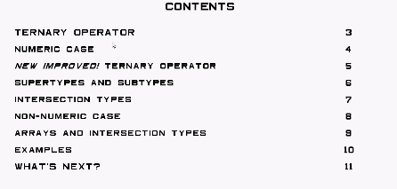

Ternary means in 3 parts

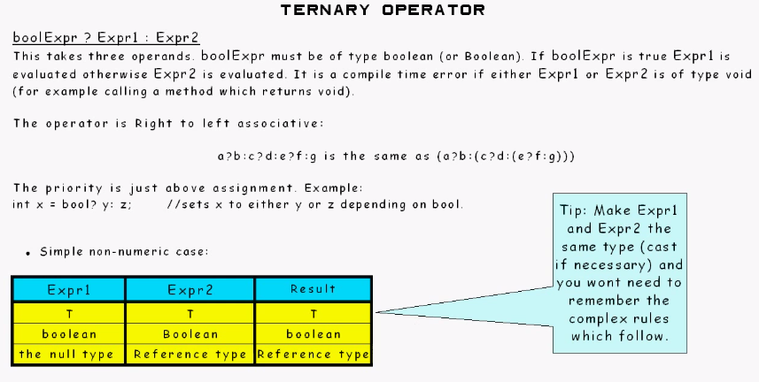

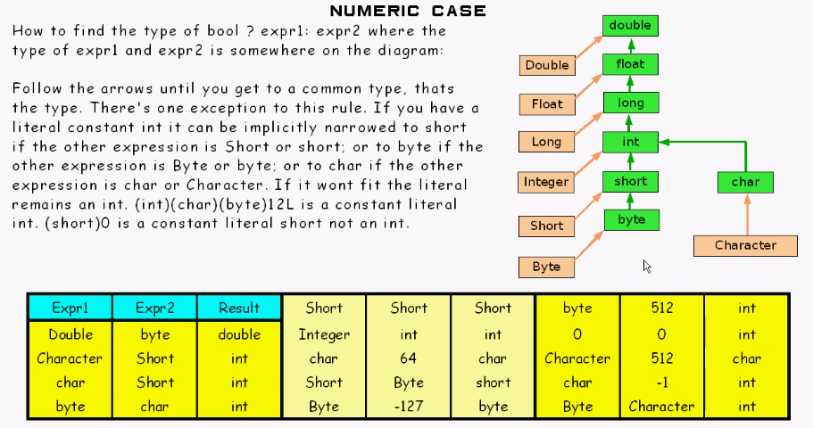

Orange arrow is unboxing.

Green arrow is widening.

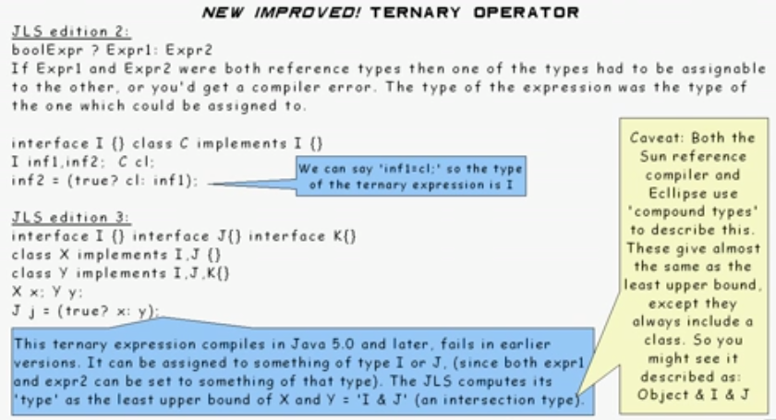

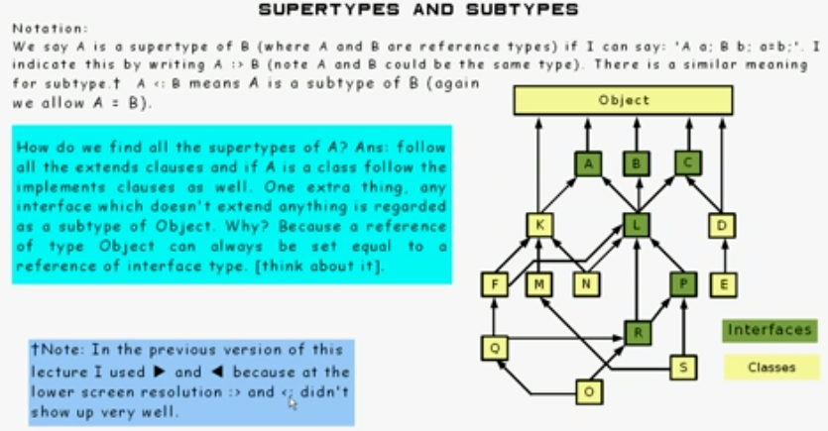

[Think about it]

1)

Reference of **interface** contains something (some sort of class which implements that **interface**). In this case, reference of Object type variable can always be set equal to a reference of **interface** type.

2)

Reference of **interface** is not set to anything, then there are 2 possibilities:

a) As a field member in some class variable of interface type set to **null**, which is OK to set with reference variable of type Object

b) As a local variable of interface type in a method not been set to anything(random), which is NOT OK to set with reference variable of type Object.

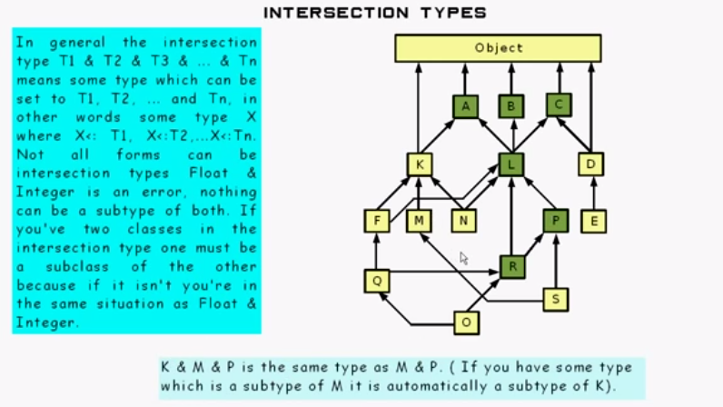

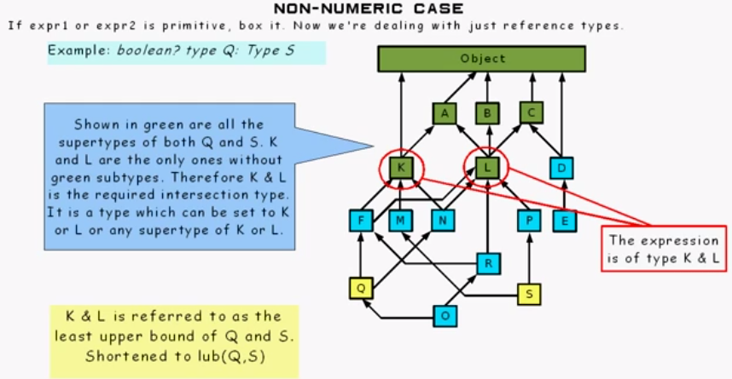

+++++++++++++++++++++++++++++++++++++++++++++++++++++++++++++++++++++++++++++++++++++++++

Enhanced For statement (From Clive Scott Videos)



++++++++++++++++++++++++++++++++++++++++++++++++++++++++++++++++++++++++++++++++++

Brief Look at TRY, ASSERT and SYNCHRONIZED statements (From Clive Scott Videos)



++++++++++++++++++++++++++++++++++++++++++++++++++++++++++++++++++++++++++++++++++

A Second Look at Classes (Access, Overriding and Hiding) (From Clive Scott Videos)

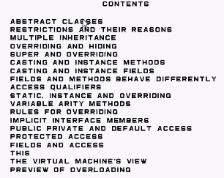

+++++++++++++++++++++++++++++++++++++++++++++++++++++++++++++++++++++

A Second Look at Classes (Overloading methods) (From Clive Scott Videos)

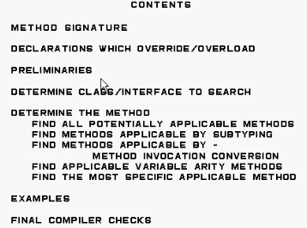

+++++++++++++++++++++++++++++++++++++++++++++++++++++++++++++++++++++

A Second Look at Classes (Constructors & Initialization) (From Clive Scott Videos)

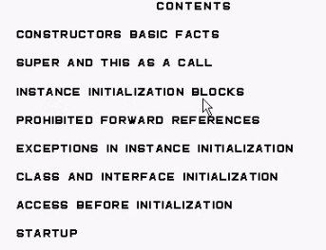

+++++++++++++++++++++++++++++++++++++++++++++++++++++++++++++++++

Nested Classes (From Clive Scott Videos)

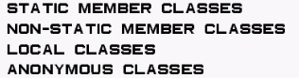

++++++++++++++++++++++++++++++++++++++++++++++++++++++++++++++++++

Numbers and Strings (From John’s video)

Every time you type \\ in the source of a Java program, it gets processed as \. No matter what class it's going into. That is just how the Java compiler works. So when you type "01\\20\\2012", you get a String whose value is 01\20\2012. And yes, you do want a regular expression with two backslashes. But because you're going to type that regular expression into a Java program, to get \\ as your regular expression, you need to type"\\\\".

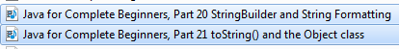

+++++++++++++++++++++++++++++++++++++++++++++++++++++++++++++++++++

Exceptions (From John’s video)

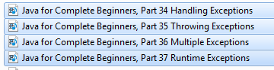

++++++++++++++++++++++++++++++++++++++++++++++++++++++++++++++++

Serialization (From John’s video)

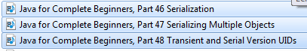

+++++++++++++++++++++++++++++++++++++++++++++++++++++++++++++++

Upcasting & Downcasting

Reference variable type determines what methods can be called for that variable.

Type of the Object decides that variable refers to determines, which actual method implementation need to be called.

Upcasting:

Machine machine2 = new Camera();

machine2.start();

//error: machine2.snap();

Downcasting(Typecast): inherently unsafe

Machine machine3 = new Camera();

Camera camera = (Camera)machine3 // Java asks for explicit typecast

Camera.snap();

Java does not allow casting parent class object typecast to child class object,

Because for below reason.

Machine machine = new Machine();

Camera camera = (Camera)machine; // Class cast exception

Camera.snap() // has no meaning

*Note: You can make a logical test as to the type of a particular object using the instanceof operator.*

*This can save you from a runtime error owing to an improper cast. For example:*

*if (obj instanceof MountainBike) {*

*MountainBike myBike = (MountainBike)obj;*

*}*

Here the instanceof operator verifies that obj refers to a MountainBike so that we can make the cast with knowledge that there will be no runtime exception thrown.

++++++++++++++++++++++++++++++++++++++++++++++++++++++++++++++++++++++++++++++++++++

Enum (From John’s video)

Why and what for: java enum

You should always use enums when a variable (especially a method parameter) can only take one out of a small set of possible values. Examples would be things like type constants (contract status: "permanent", "temp", "apprentice"), or flags ("execute now", "defer execution").

If you use enums instead of integers (or String codes), you increase compile-time checking and avoid errors from passing in invalid constants, and you document which values are legal to use.

BTW, overuse of enums might mean that your methods do too much (it's often better to have several separate methods, rather than one method that takes several flags which modify what it does), but if you have to use flags or type codes, enums are the way to go.

As an example, which is better?

/** Counts number of foobangs.

* @param type Type of foobangs to count. Can be 1=green foobangs,

* 2=wrinkled foobangs, 3=sweet foobangs, 0=all types.

* @return number of foobangs of type

*/

public int countFoobangs(int type)

versus

/** Types of foobangs. */

public enum FB_TYPE {

GREEN, WRINKLED, SWEET,

/** special type for all types combined */

ALL;

}

/** Counts number of foobangs.

* @param type Type of foobangs to count

* @return number of foobangs of type

*/

public int countFoobangs(FB_TYPE type)

In the second example, it's immediately clear which types are allowed, docs and implementation cannot go out of sync, and the compiler can enforce this.

**Introduction to Enums**

The enumeration is a way of creating self-documenting code, a big improvement over the "magic" integer or string constants which are often used to represent a defined set of values. Enumerations abound in object models, and examples are not hard to find: days of the week, colors, card suits, etc. The idea of enumerations as an actual programming language type goes back to Pascal. Many programmers, though, are likely to be more familiar with the C/C++ version of it as the enum, which is just a decorated integer:

//use optional assignment to ints to illustrate

enum suit {

SPADES = 1,

HEARTS = 2,

DIAMONDS = 3,

CLUBS = 4

};

Figure 1: C/C++ enum

**Enums in Java**

In Java, the introduction of enumerations started informally with Joshua Bloch's [type-safe enumeration pattern](http://http/books.google.com/books?id=ZZOiqZQIbRMC&dq=joshua+block+effective+java&pg=PP1&ots=UYT1asfI6Z&sig=IB1zFDMDvZMoXFtlejC706KNha4&prev=http://www.google.com/search%3Fq%3DJoshua%2BBlock%2BEffective%2BJava%26ie%3Dutf-8%26oe%3Dutf-8%26aq%3Dt%26rls%3Dorg.mozilla:en-US:official%26client%3Dfirefox-a&sa=X&oi=print&ct=title&cad=one-book-with-thumbnail). The pattern boils down to essentially this: a Java class with a private constructor that declares public static final versions of itself.

public final class Suit {

private Suit() {}

public static final Suit SPADES = new Suit();

public static final Suit HEARTS = new Suit();

public static final Suit DIAMONDS = new Suit();

public static final Suit CLUBS = new Suit();

}

Figure 2: The type-safe enumeration pattern

The advantage of this style of enumeration over the C/C++-style enum or constants is that they are "type-safe", meaning that, for example, if you define a method

public void setSuit(Suit suit) { ... }

the caller cannot pass in a value that does not correspond to an enumeration value. With a constant or C/C++-style enum, you could pass in a random value (like -1) that would not. Java-style enumerations have the additional advantage that, since they are classes, you can "associate" other data with them. This idea will be illustrated a little later. Since these enumeration instances are all effectively singletons, they can be compared for equality using identity ("==").

**Enums in Java 5.0**

In Java 5.0, the enum keyword is introduced as a special type of class that always extends java.lang.Enum. These closely resemble an abbreviated version of Bloch's type-safe enumeration pattern.

public enum Suit {

SPADES,

HEARTS,

DIAMONDS,

CLUBS //optionally can end with ";"

}

Figure 3: The Java 5.0 enum

The difference is that this version includes utility methods like name() that returns the declared variable name as a String, ordinal() that returns the position of theenum as it is declared in the class, and valueOf() which allows you to look up theenum using its declared variable name as a String. Java 5.0 enumerations also can be used in switch statements, a nice convenience. Note that the enumeration values are still static class members, though not declared as such.

So, going beyond the basics, what can you do with Java enumerations? Here are a few handy tricks...

**Enums and Template Methods**

Remember that the enum is basically a special class type, and can have methods and fields just like any other class. Remember also that each declared field is also an instance of the enum. So, applying the ["Template Method" design pattern](http://en.wikipedia.org/wiki/Template_method_pattern), one can create enumerations that are factories or command objects, but a defined setof objects. Here is a simple example of a "command" enumeration:

public enum Toy {

DOLL() {

@Override public void execute() {

System.out.println("I'm a doll.");

}

},

SOLDIER() {

@Override public void execute() {

System.out.println("I'm a soldier.");

}

};

//template method

public abstract void execute();

}

Figure 4: The enum with template method

With the use of [static imports](http://java.sun.com/j2se/1.5.0/docs/guide/language/static-import.html), the client code calling this enumeration would look like:

SOLDIER.execute();

DOLL.execute();

//or better...

getToy().execute();

The resulting code is clear and self-documenting. Using this pattern is a great alternative in many cases to the more common if(toy=="soldier"){...} else if(toy=="doll"){...} else{...} logic since it is easier to read, extend, and maintain.

**Reverse Lookups**

Often in your object model it is common to have data that is naturally "associated" with an enumeration. Since an enum is a class, it is easy to represent this associated information as class fields. Often it is desirable to "lookup" the associated enumeration using the field value. This is easy to do using a staticjava.util.Map. Take, for example, a Status enum that has an associated status code.

public enum Status

{

WAITING(0),

READY(1),

SKIPPED(-1),

COMPLETED(5);

private static final Map<Integer,Status> lookup

= new HashMap<Integer,Status>();

static {

for(Status s : EnumSet.allOf(Status.class))

lookup.put(s.getCode(), s);

}

private int code;

private Status(int code) {

this.code = code;

}

public int getCode() { return code; }

public static Status get(int code) {

return lookup.get(code);

}

}

Figure 5: The enum reverse lookup

The static get(int) method here provides the reverse lookup by simply getting the value from the Map. The static block to populate the Map uses a specialized implementation of Set, java.util.EnumSet, that "probably" (according to the javadocs) has better performance than java.util.HashSet. Java 5.0 also providesjava.util.EnumMap, a specialized implementation of Map for enumerations that is more compact than java.util.HashMap.

**Conclusion**

The enum in Java 5.0 represents a cleaner, more self-documenting, richer, and in many cases, more efficient way of coding certain object model concepts than was possible using the older idiom of static final constants. Even if you are still using Java 1.4.x or earlier, you can still gain many of the benefits of the enum by using the type-safe enumeration pattern; this will also make the code easier to migrate once you do go to Java 5.0. Older client code that uses constants can still be adapted to use the enum by associating constant values with the enumerations themselves (as seen in the Status class, Figure 5). So, in other words, there is no reason not to convert your old static constants to enumerations. The guy who has to maintain your code will thank you.

"Hello World!" examples are great for general introductions to a concept, but often tend to lack much depth. So, as a follow-up to the original [article](http://www.ajaxonomy.com/2007/java/making-the-most-of-java-50-enum-tricks) on enums in Java 5.0, this article goes into a little more depth with a real-world example.

**The Container Enum**

Figure 1 below illustrates the enumeration of possible application servers to which an application can deploy. Why is this useful? Many organizations have more than one Java application server in different environments, and an EAR or WAR may need to be redeployed to different servers; or, you may be developing a common framework that will be used in different environments. It is often helpful in these situations to abstract many of the (static) variances between containers so that redeployment to a different environment can be done with a minimum of effort.

Figure 1: The Container enum.

public enum Container {

WEBSPHERE, WEBLOGIC, JBOSS, NONE;

}

Now, let's say the application being designed requires an application-controlled JTA TransactionManager (if, for example, the standard way of doing XA transactions cannot be used). But how one is acquired varies pretty widely, depending on which environment the code is running. The variances here can be handled with an abstract method added to the enum, as in Figure 2.

Figure 2: The Container enum with factory methods.

public enum Container

{

WEBSPHERE() {

private String[] factoryNames =

{"com.ibm.ws.Transaction.TransactionManagerFactory",

"com.ibm.ejs.jts.jta.TransactionManagerFactory",

"com.ibm.ejs.jts.jta.JTSXA"};

@Override

public TransactionManager getTransactionManager()

throws Exception {

for (int i = 0; i < factoryNames.length; i++) {

Method getTxMgr = null;

try {

//attempt to get class and method

Class<?> txMgrFactory = Class.forName(factoryNames[i]);

getTxMgr = txMgrFactory

.getMethod("getTransactionManager", null);

} catch (Exception e) {

continue;

}

//attempt to invoke method (let exception throw...)

return (TransactionManager) getTxMgr.invoke(null, null);

}

//if all else fails

return null; //or throw exception

}

},

WEBLOGIC() {

@Override

public TransactionManager getTransactionManager()

throws Exception {

InitialContext ctx = null;

try {

ctx = new InitialContext();

return (TransactionManager) ctx

.lookup("java:comp/UserTransaction");

} finally {

if(ctx!=null) {

try { ctx.close(); } catch (NamingException e) {}

}

}

}

},

JBOSS() {

@Override

public TransactionManager getTransactionManager()

throws Exception {

InitialContext ctx = null;

try {

ctx = new InitialContext();

return (TransactionManager) ctx

.lookup("java:/TransactionManager");

} finally {

if(ctx!=null) {

try { ctx.close(); } catch (NamingException e) {}

}

}

}

},

// Standalone environ or server w/o TM

NONE() {

@Override

public TransactionManager getTransactionManager()

throws Exception {

//Use reflection to avoid necessary dependency

Class<?> clazz = Class.forName("org.objectweb.jotm.Jotm");

Constructor<?> constr = clazz.getConstructor(boolean.class,

boolean.class);

Object jotm = constr.newInstance(true, false);

Method getTxMgr = clazz.getMethod("getTransactionManager",

(Class[])null);

return TransactionManager.class.cast(getTxMgr

.invoke(jotm, (Object[])null));

}

};

// abstract method

public abstract TransactionManager getTransactionManager()

throws Exception;

}

Here we are defining an abstract method getTransactionManager() as a factory method for getting or creating a JTA TransactionManager in a manner similar to the Spring Framework's [JtaTransactionManager](http://www.koders.com/java/fid4F596512E71BAACCBB76EA6045AF265FD137581D.aspx). Each enumeration instance must implement this method. In most cases, a JEE-compliant server will have a JNDI lookup that can be used. For WebSphere, there is no API for gettng aTransactionManager directly, but instead a time-honored backdoor for creating one. In the case of NONE (either a stand-alone environment or a server that has noTransactionManager), [JOTM](http://jotm.objectweb.org/) is used. Of course, the enum would be a lot shorter if the calls were delegated to factory classes, but that's an implementation detail.

Since the JMX default domain for most major Java application servers is self-describing, something like the following snippet of code can be used to "auto-sniff" the container environment:

public Container lookupContainer() {

String defaultDomain = ManagementFactory

.getPlatformMBeanServer()

.getDefaultDomain();

try {

return Container.valueOf(defaultDomain.toUpperCase());

} catch (Exception e) { /*...assume none....*/ }

return Container.NONE; // or null if no default behavior

}

After all of that, the client code to use it is a simple line:

lookupContainer().getTransactionManager():

**Conclusion**

The Container enum is a good illustration of the power of enumerations in Java compared to their C/C++ counterparts. By associating behavior with each enum instance, a smooth way of dispatching getTransactionManager() to the appropriate implementation has been created. This points out another fact: each enum instance (WEBSPHERE, WEBLOGIC, etc.) is implicitly a subclass of the enum class Container itself. This comes in handy since it means that many other object-oriented design patterns (Abstract Factory, Command, Visitor, and Strategy, to name a few) can be implemented using enums. Those, of course, are left as an exercise to the reader.



+++++++++++++++++++++++++++++++++++++++++++++++++++++++++++++++++++++

Interface (Charles video)



+++++++++++++++++++++++++++++++++++++++++++++++++++++++++++++++++++++

Generics in the next doc (From Clive Scott Videos & Oracle Java doc)

Content is in generics.doc

+++++++++++++++++++++++++++++++++++++++++++++++++++++++++++++++++

File access (Charles video)

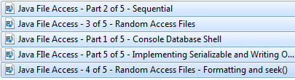

+++++++++++++++++++++++++++++++++++++++++++++++++++++++++++++++

JDBC (Charles video)

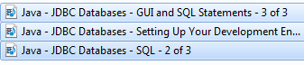

++++++++++++++++++++++++++++++++++++++++++++++++++++++++++++++++

Java JNI ([Matthias Büchner](http://www.blogger.com/profile/03993705703169676412) video)

<http://docs.oracle.com/javase/7/docs/technotes/guides/jni/spec/jniTOC.html>



+++++++++++++++++++++++++++++++++++++++++++++++++++++++++++++++++

Reflections (Derek Banas & David Whitlock video)

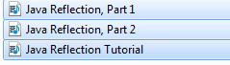

+++++++++++++++++++++++++++++++++++++++++++++++++++++++++++++++++

Java Collection (From John’s video)

CS 61B berkeley

You have created an Arraylist and then converted it into an Array. But your list was empty.

Collection<String> c = **new** ArrayList<String>();

String[] str = c.toArray(**new** String[0]);

Here is similar code where, ArrayList is not empty.

Collection<String> c = **new** ArrayList<String>();

c.add("abc");

c.add("def");

String[] str = c.toArray(**new** String[c.size()]);

+++++++++++++++++++++++++++++++++++++++++++++++++++++++++++++++++

Multi-Threading (From John’s video)

15 videos on multi-threading

+++++++++++++++++++++++++++++++++++++++++++++++++++++++++++++++++

**What is null?**

As the JLS quote above says, in practice you can simply pretend that it's "merely a special literal that can be of any reference type".

In Java, null == null (this isn't always the case in other languages). Note also that by contract, it also has this special property (from [java.lang.Object](http://java.sun.com/javase/6/docs/api/java/lang/Object.html" \l "equals%28java.lang.Object%29)):

public boolean equals(Object obj)

For any non-null reference value x, x.equals(null) should return false.

It is also the default value (for variables that have them) for all reference types:

### [JLS 4.12.5 Initial Values of Variables](http://java.sun.com/docs/books/jls/third_edition/html/typesValues.html#4.12.5)

* Each class variable, instance variable, or array component is initialized with a default value when it is created:
  + For all reference types, the default value is null.

How this is used varies. You can use it to enable what is called lazy initialization of fields, where a field would have its initial value of null until it's actually used, where it's replaced by the "real" value (which may be expensive to compute).

There are also other uses. Let's take a real example from [java.lang.System](http://java.sun.com/javase/6/docs/api/java/lang/System.html" \l "console%28%29):

public static Console console()

**Returns**: The system console, if any, otherwise null.

This is a very common use pattern: null is used to denote non-existence of an object.

Here's another usage example, this time from [java.io.BufferedReader](http://java.sun.com/javase/6/docs/api/java/io/BufferedReader.html" \l "readLine%28%29):

public String readLine() throws IOException

**Returns**: A String containing the contents of the line, not including any line-termination characters, or null if the end of the stream has been reached.

So here, readLine() would return instanceof String for each line, until it finally returns a nullto signify the end. This allows you to process each line as follows:

String line;

while ((line = reader.readLine()) != null) {

process(line);

}

One can design the API so that the termination condition doesn't depend on readLine() returningnull, but one can see that this design has the benefit of making things concise. Note that there is no problem with empty lines, because an empty line "" != null.

Let's take another example, this time from [java.util.Map<K,V>](http://java.sun.com/javase/6/docs/api/java/util/Map.html" \l "get%28java.lang.Object%29):

V get(Object key)

Returns the value to which the specified key is mapped, or null if this map contains no mapping for the key.

If this map permits null values, then a return value of null does not necessarily indicate that the map contains no mapping for the key; it's also possible that the map explicitly maps the key to null. The containsKey operation may be used to distinguish these two cases.

Here we start to see how using null can complicate things. The first statement says that if the key isn't mapped, null is returned. The second statement says that even if the key is mapped, null can alsobe returned.

In contrast, [java.util.Hashtable](http://java.sun.com/javase/6/docs/api/java/util/Hashtable.html) keeps things simpler by not permitting null keys and values; itsV get(Object key), if returns null, unambiguously means that the key isn't mapped.

You can read through the rest of the APIs and find where and how null is used. Do keep in mind that they aren't always the best practice examples.

Generally speaking, null are used as a special value to signify:

* Uninitialized state
* Termination condition
* Non-existing object
* An unknown value

*What set does 'null' belong to?*

### [JLS 4.1 The Kinds of Types and Values](http://java.sun.com/docs/books/jls/third_edition/html/typesValues.html#4.1)

There is also a special null type, the type of the expression null, which has no name. Because thenull type has no name, it is impossible to declare a variable of the null type or to cast to the null type. The null reference is the only possible value of an expression of null type. The null reference can always be cast to any reference type. In practice, the programmer can ignore the null type and just pretend that null is merely a special literal that can be of any reference type.

*Is null an instance of anything?*

No, there is no type which null is an instanceof.

### [15.20.2 Type Comparison Operator instanceof](http://java.sun.com/docs/books/jls/third_edition/html/expressions.html#15.20.2)

RelationalExpression:

RelationalExpression instanceof ReferenceType

At run time, the result of the instanceof operator is true if the value of the RelationalExpressionis not null and the reference could be cast to the ReferenceType without raising aClassCastException. Otherwise the result is false.

This means that for any type E and R, for any E o, where o == null, o instanceof R is always false.

-------------------------------------------------------------------------------------------------------------------------------------------------------

Abstraction/Encapsulation

Abstraction is the technique of hiding implementation. At it's core there's not much more to that answer. The bulk of meaning to abstraction come from how and why it is used.

It is used for the following scenarios

* Reduce complexity. (Create a simple interface)
* Allow for implementation to be modified without impacting its users.
* Create a common interface to support polymorphism (treating all implementations of the abstracted layer the same.
* Force users to extend the implementation rather than modify.
* Support cross platform by changing the implementation per platform.

Another definition of Abstraction:

Abstraction is the elimination of the irrelevant and the amplification of the essential.

Based on that definition, and abstraction can take many forms, on many different levels:

* It can be an entire system
* It can be a subsystem
* It can be a definition of a message format (akin to a protocol)
* It can be a function (as in Functional Programming)
* It can be an abstract base class
* It can be an interface
* It can be a concrete class
* etc.

In [Object-Oriented Software Construction](http://amzn.to/1claOin), Bertrand Meyer describes classes as Abstract Data Types. The idea in this book is that the description of an Abstract Data Type includes pre- and post-conditions. In Eiffel (the language used in the book), these are called assertions, but we also know them as**invariants**.

Meyer's view on Object-Oriented Design includes invariants. On a detailed (class/object/function) level, I agree that it makes sense to view invariants as a way to **describe** an abstraction.

On the other hand, if your abstraction is a description of a high-level architecture, that sort of invariants doesn't make sense. Still, even on a high level, it would often be valuable to define pre- and post-condition (e.g. "System A must be responding in order for System B to work correctly"), so it does makes sense to think about invariants in relation to abstractions.

//////////////////////////////////////////////////////

What is the precise difference between encapsulation and abstraction?

A priori, they've got nothing in common.

Most answers here focus on OOP but encapsulation begins much earlier; **every method is an encapsulation**:

point x = { 1, 4 };

point y = { 23, 42 };

int d = distance(x, y);

Here, distance encapsulates the calculation of the (euclidean) distance between two points in a plane: it hides implementation details. This is encapsulation, pure and simple.

**Abstraction** is the process of *generalization*: taking a concrete implementation and making it applicable to different, albeit somewhat related, types of data. The classical example of abstraction is C's qsort function which sorts data.

The thing about qsort is that it doesn't care about the data it sorts – in fact, it **doesn't know** what data it sorts. Rather, its input type is a typeless pointer (void*) which is just C's way of saying “I don't care about the type of data” (this is also called type erasure). The important point is that the implementation of qsort always stays the same, regardless of data type. The only thing that *has* to change is the compare function, which differs from data type to data type. qsort therefore expects the user to provide said compare function as a function argument.

-------------------------------------------------------------------------------------------------------------------------------------------------------

**What is the difference between swing and awt?**

AWT is a Java interface to native system GUI code present in your OS. It will not work the same on every system, although it tries.

Swing is a more-or-less pure-Java GUI. It uses AWT to create an operating system window and then paints pictures of buttons, labels, text, checkboxes, etc., into that window and responds to all of your mouse-clicks, key entries, etc., deciding for itself what to do instead of letting the operating system handle it. Thus Swing is 100% portable and is the same across platforms (although it is skinnable and has a "pluggable look and feel" that can make it look more or less like how the native windows and widgets would look).

These are vastly different approaches to GUI toolkits and have a lot of consequences. A full answer to your question would try to explore all of those. :) Here are a couple:

AWT is a cross-platform interface, so even though it uses the underlying OS or native GUI toolkit for its functionality, it doesn't provide access to everything that those toolkits can do. Advanced or newer AWT widgets that might exist on one platform might not be supported on another. Features of widgets that aren't the same on every platform might not be supported, or worse, they might work differently on each platform. People used to invest lots of effort to get their AWT applications to work consistently across platforms - for instance, they may try to make calls into native code from Java.

Because AWT uses native GUI widgets, your OS knows about them and handles putting them in front of each other, etc., whereas Swing widgets are meaningless pixels within a window from your OS's point of view. Swing itself handles your widgets' layout and stacking. Mixing AWT and Swing is highly unsupported and can lead to ridiculous results, such as native buttons that obscure everything else in the dialog box in which they reside because everything else was created with Swing.

Because Swing tries to do everything possible in Java other than the very raw graphics routines provided by a native GUI window, it used to incur quite a performance penalty compared to AWT. This made Swing unfortunately slow to catch on. However, this has shrunk dramatically over the last several years due to more optimized JVMs, faster machines, and (I presume) optimization of the Swing internals. Today a Swing application can run fast enough to be serviceable or even zippy, and almost indistinguishable from an application using native widgets. Some will say it took far too long to get to this point, but most will say that it is well worth it.

Finally, you might also want to check out SWT (the GUI toolkit used for Eclipse, and an alternative to both AWT and Swing), which is somewhat of a return to the AWT idea of accessing native Widgets through Java.

----------------------------------------------------------------------------------------------------------------------------------------------------------------------------------------